

Practices for Secure Software Report

Table of Contents
Document Revision History 3
Client 3
Instructions 3
Developer 4
1. Algorithm Cipher 4
2. Certificate Generation 4
3. Deploy Cipher 4
4. Secure Communications 4
5. Secondary Testing 4
6. Functional Testing 4
7. Summary 4
8. Industry Standard Best Practices 4

Document Revision History

Version | Date | Author | Comments
1.0 | 6/21/2026 | Kyle McCrea

Client



Instructions

Submit this completed practices for secure software report. Replace the bracketed text with the relevant information. You must document your process for writing secure communications and refactoring code that complies with software security testing protocols.

- Respond to the steps outlined below and include your findings.
- Respond using your own words. You may also choose to include images or supporting materials. If you include them, make certain to insert them in all the relevant locations in the document.
- Refer to the Project Two Guidelines and Rubric for more detailed instructions about each section of the template.

Developer
Kyle McCrea

Algorithm Cipher

For the checksum verification of your transmitted financial data for Artemis Financial, I would recommend SHA-256, which is a member of the Secure Hash Algorithm 2 (SHA-2) family. This was developed by the National Security Agency (NSA) and is now standardized by the National Institute of Standards and Technology (NIST). The SHA-256 algorithm will produce a fixed 256-bit hash value from any input data. A minute/crucial change in original data will result in an entirely different hash value thereby proving collission-resistence property ideal for determining data integrity verification.

Similarly, SHA-256 is called a one-way hash function hence from the hash value original data cannot be re-constructed. In your project, SHA-256 must have been used to produce checksum in order to verify whether your data transmitted has been altered or not. Matching of checksum indicates data is not altered.

In general, modern security systems inclulcate both of these security mechanism i.e., hashfunction and encryption algorithms. A symmetric encryption (AES-256) which uses a single key for both encryption and de-cryption is commonly used to protect stored data. Asymmetric encryption which uses a public-private key pair is commonly used for SSL/TLS certificates to create a secure communication channel. Besides, a precaution also has to be taken in randomly generating no.s as well because a secure key should depend on unpredictable values to resist the attack.

Generally, regarding collission attack, the earlier version of hash function such as MD5 and SHA-1 are now declared in-secure. The SHA-256 hashfunction is still widely trusted and is taken in use for generating digital signatures, SSL/TLS certificates, blockchain technology, and integrity checking of files.

Keeping in view of your organization Artemis Financial which requires to protect the identity of transmitted financial data. SHA-256 will be the best choice for you given its substantial collision resistance, well-known industry acceptance, and capability to detect un-authorized changes in data.

Certificate Generation
Insert a screenshot below of the CER file.

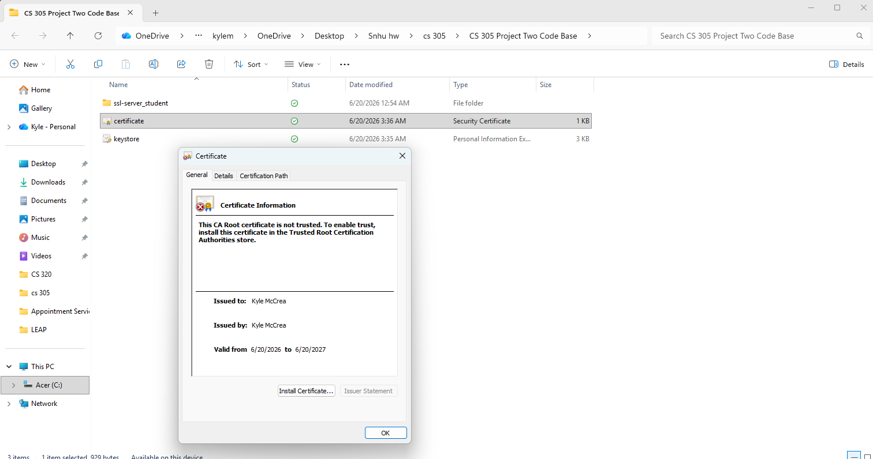

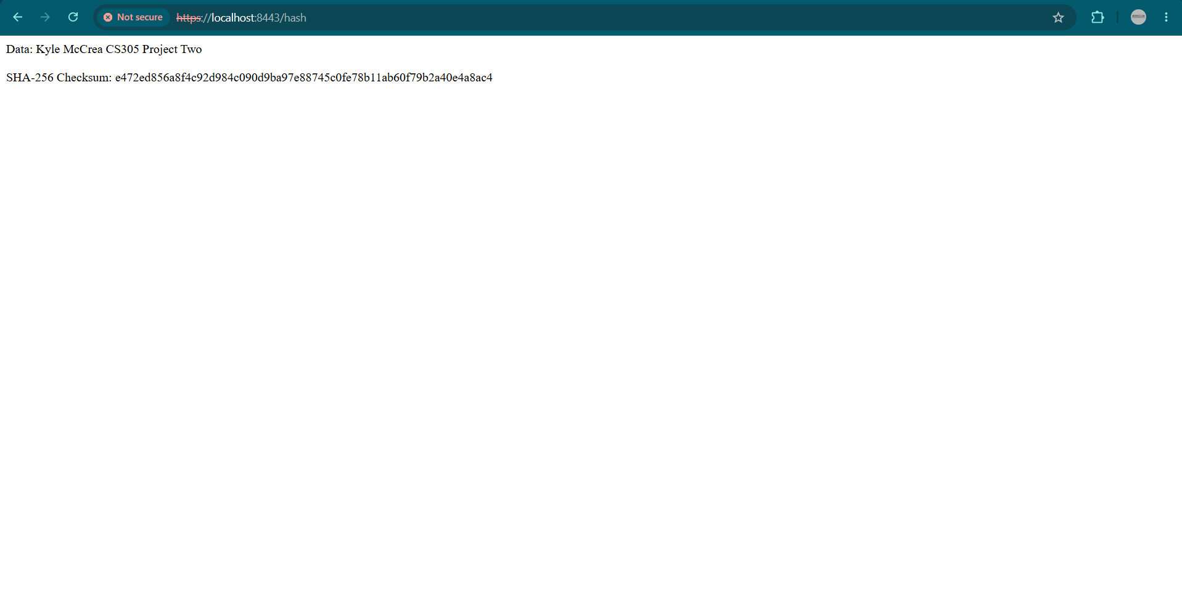
Deploy Cipher
Insert a screenshot below of the checksum verification.

Secure Communications
Insert a screenshot below of the web browser that shows a secure webpage.



Secondary Testing
Insert screenshots below of the refactored code executed without errors and the dependency-check report.

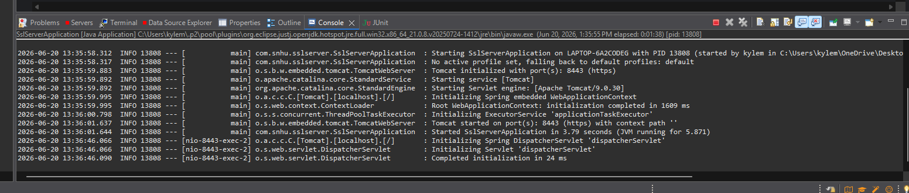

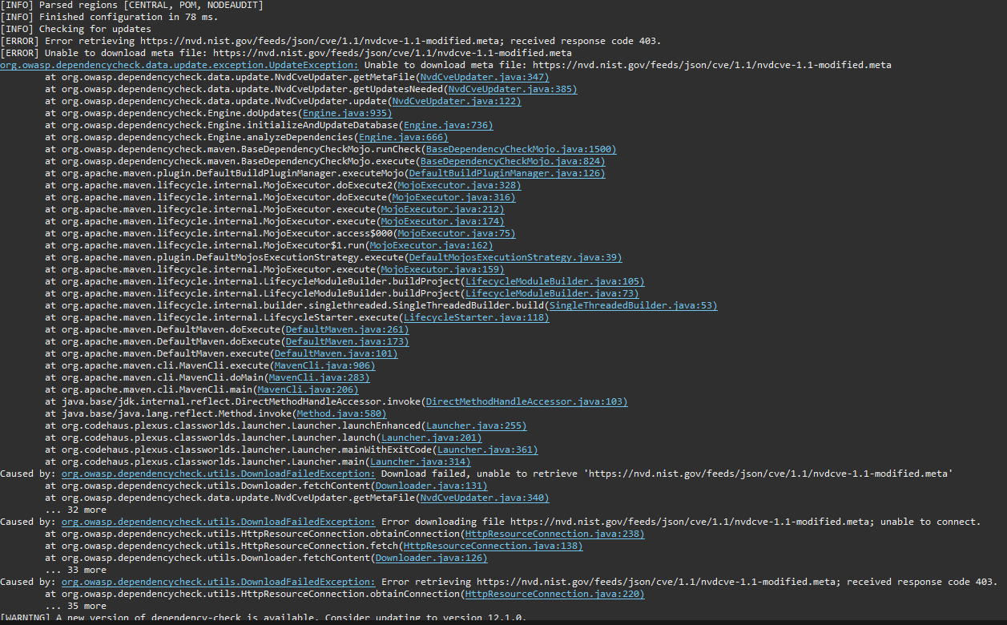

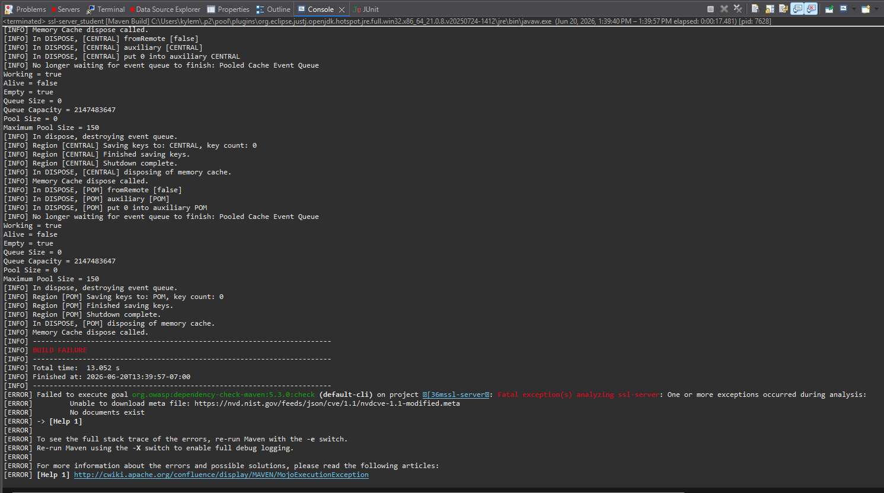

Functional Testing
Insert a screenshot below of the refactored code executed without errors.



Summary

We successfully refactored the Artemis Financial application to protect against tampering and to adhere to secure software development standards. Multiple security areas were addressed during the project: ensuring the integrity of transmitted data, communicating in a secure manner, managing X.509v3 self-signed SSL/TLS certificates, and detecting and managing the most recent security vulnerabilities. After the vulnerability assessment model phase identified flaws in communication security and in missing data verification, these weaknesses were removed by adding HTTPS server/client communication and data SHA-256 message-digest checks.

We incorporated a checksum to verify transmitted data has not been altered or corrupted. An X.509v3 self-signed SSL/TLS certificate was generated and embedded within the application to enable HTTPS transmissions. Execution also incorporated the OWASP Dependency-Check to check for server/client project component dependencies containing publicly known security vulnerabilities. After the code was refactored and the security enhancements were included, the functional application and the added security features and testing run successfully.

The refactored application easily fell into the suite of security testing since the design incorporated the O/J Land (1979) functional testing strategy along with static analysis including the Dependency-Check to review the building components for potential vulnerabilities. Functional testing validated the application was compiled and executed properly while implementing server/client secure HTTPS communications. Static analysis tested this by running the Dependency-Check to review the server/client project components and determine if any had publicly known vulnerabilities. The type and coverage of the testing required to confirm the functional and secure enhancements required no changes to other parts of the application including the checksum.

Industry Standard Best Practices

We followed industry-standard secure coding practices throughout the refactoring process to ensure that the Artemis Financial application was and remains secure. For instance, we used HTTPS to encrypt all communications between the client and server. We created and configured an SSL/TLS certificate to activate HTTPS support, meaning emptry/shopping/sensitive data is protected from eavesdropping and tampering. We also used the SHA-256 cryptographic hash algorithm to perform a checksum on all transmitted data, adding another level of protection against eavesdropping and tampering.

We used third-party software component security checks as another secure coding practice. While we used the OWASP Dependency-Check to scan the project dependencies for vulnerabilities as best as we could, the tool faced an issue fetching the latest vulnerability data from the National Vulnerability Database. Still, it’s a good idea to run the tool every time a new library is included into a project, or at least occasionally to check if there are publicly known vulnerabilities that you should be protected against. The fewer libraries included in your solution, the smaller the attack surface.

The application had to be functional throughout the security enhancements, so only the necessary changes were made in each area. The changes were isolated to interfere as little as possible with existing behaviors. Also, after each major security change we ran a series of functional security tests to confirm that our fixes did not impact the operation of the application and that the extra level of protection was in place.

Secure coding practices have brought and will continue to bring proper value to our customers and to Artemis Financial. By using secure communications, verifying data integrity, performing vulnerability checks on third-party software components, and intentionally running functional tests, sensitive customer data is protected against eavesdropping, tampering, and known attack vectors to the best of our knowledge and abilities. The risk of security spills, including loss of customer trust and regulatory penalties, is also significantly reduced.

